**Team Kick ASCII**

**Jennifer Dunham, Hyo Lee, Daniel Cadwell, Francisco Gutierrez**

**~Spring 2015~**

**CST363 Introduction to Database Systems**

**Class project**

**Part 1**

**Project description**

In this project, you are to apply what we have learned to design and implement a database system for an organization/company of your choice, it could be a library, restaurant, car repair shop, pet clinic etc. In the first part of the project, you are required to:

1) Provide a summary of the scope of your project: brief description of the organization, information needs and questions that need to be addressed, and the purpose of your database system.

Our organization, Kick ASCII Sporting Goods, is a sporting goods wholesaler. We supply sporting goods to retail stores. We need to ensure that we can track our customers, suppliers, products, and sales transactions. The purpose of our database is to implement a system to manage our business using the following business rules:

* Each retail store may have one or more contacts.
* Each retail store may have one or more invoices.
* A Sales Rep may write one or more invoices.
* An invoice is written by one Sales Rep.
* Each invoice has one store
* The store manager must be one of the contacts we have on file.
* Each contact is employed by one retail store.
* Each invoice is generated by one contact.
* Each invoice line may include one or more products.
* Each invoice line includes one or more invoices.
* Each product is supplied by one vendor.
* A vendor may supply one or more products.
* Each category may have one or more products (i.e., sport).

[Data Dictionary Hyperlink](https://docs.google.com/a/csumb.edu/spreadsheets/d/1hjNmD-KC3AfJzpfWaFsaIo_-ExFjZvBDChGF6UDUsl4/edit?usp=sharing)

2) Draw ER diagram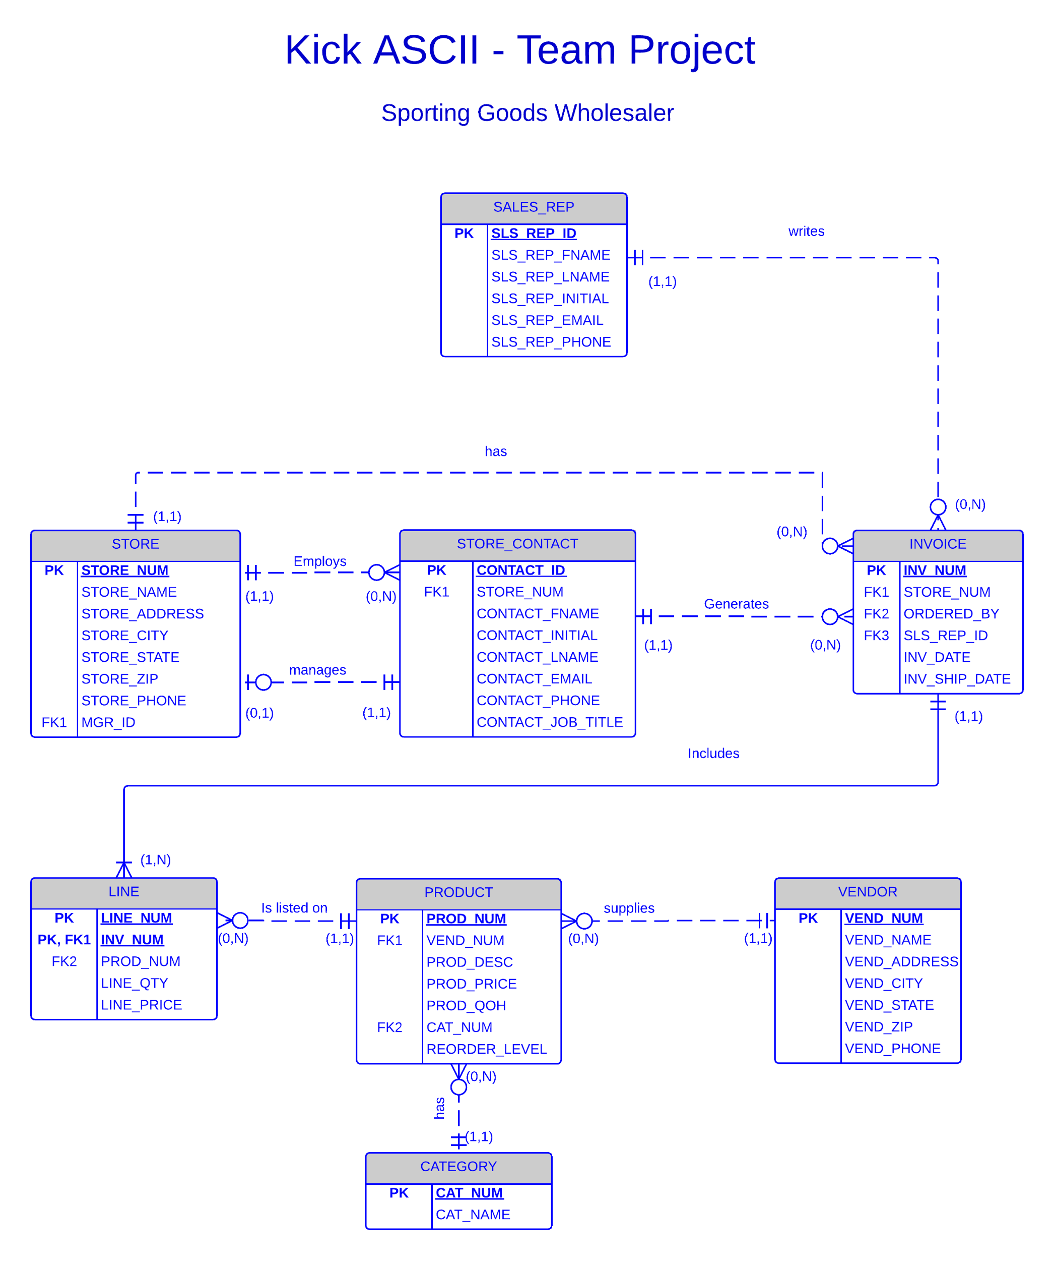

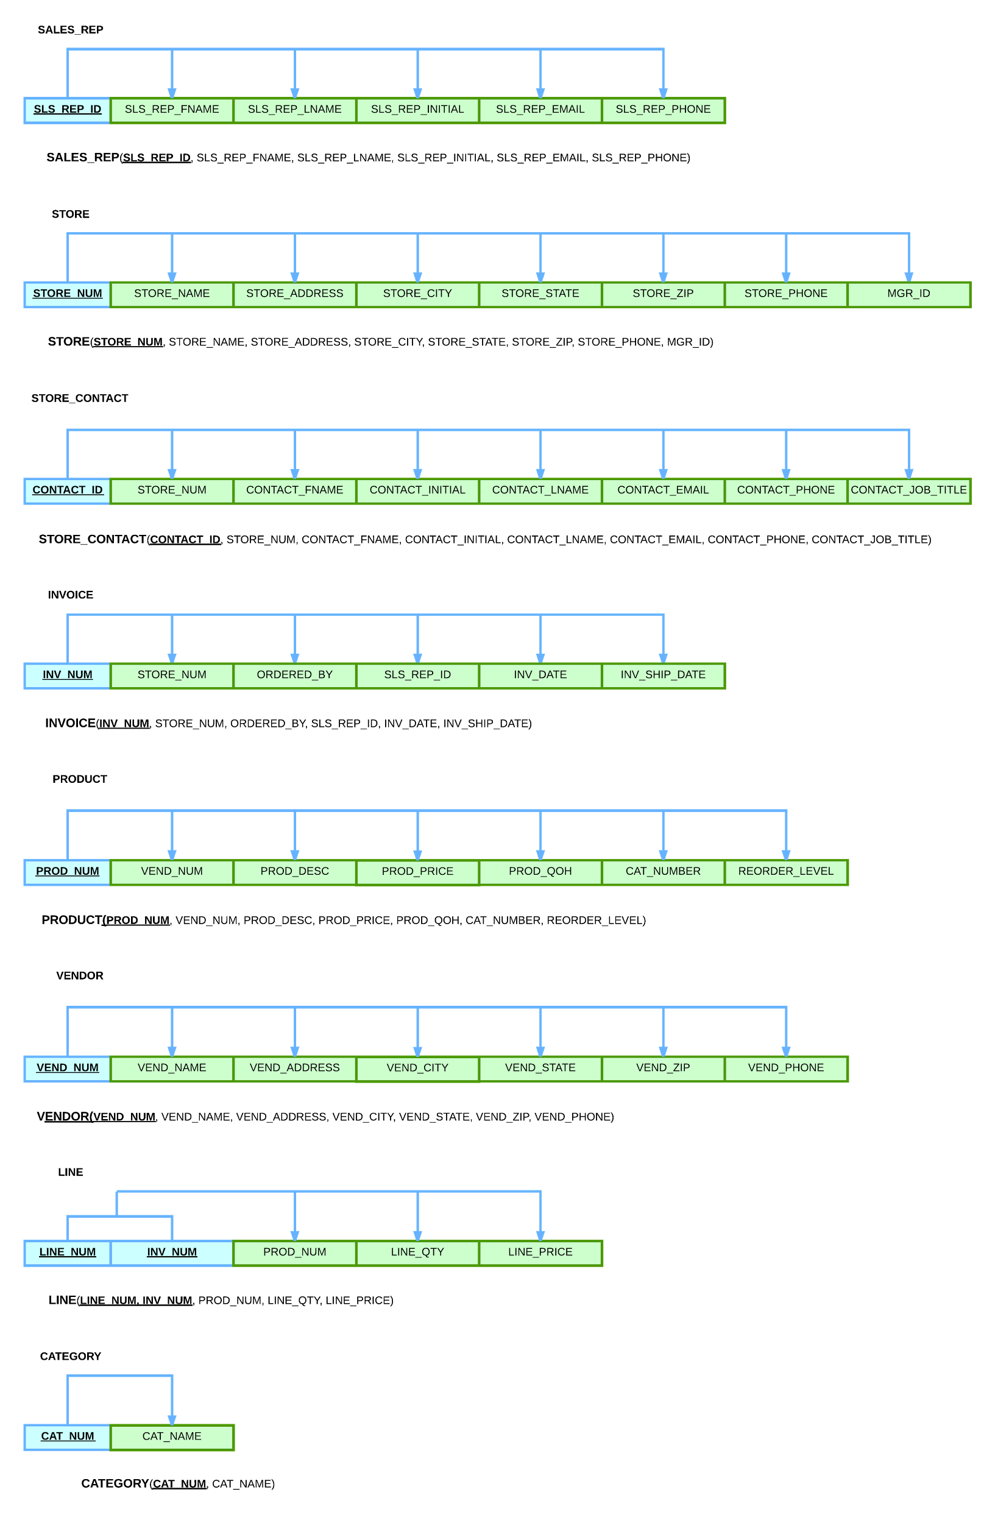 3) Convert the ER diagram into tables in their 3rd normal form